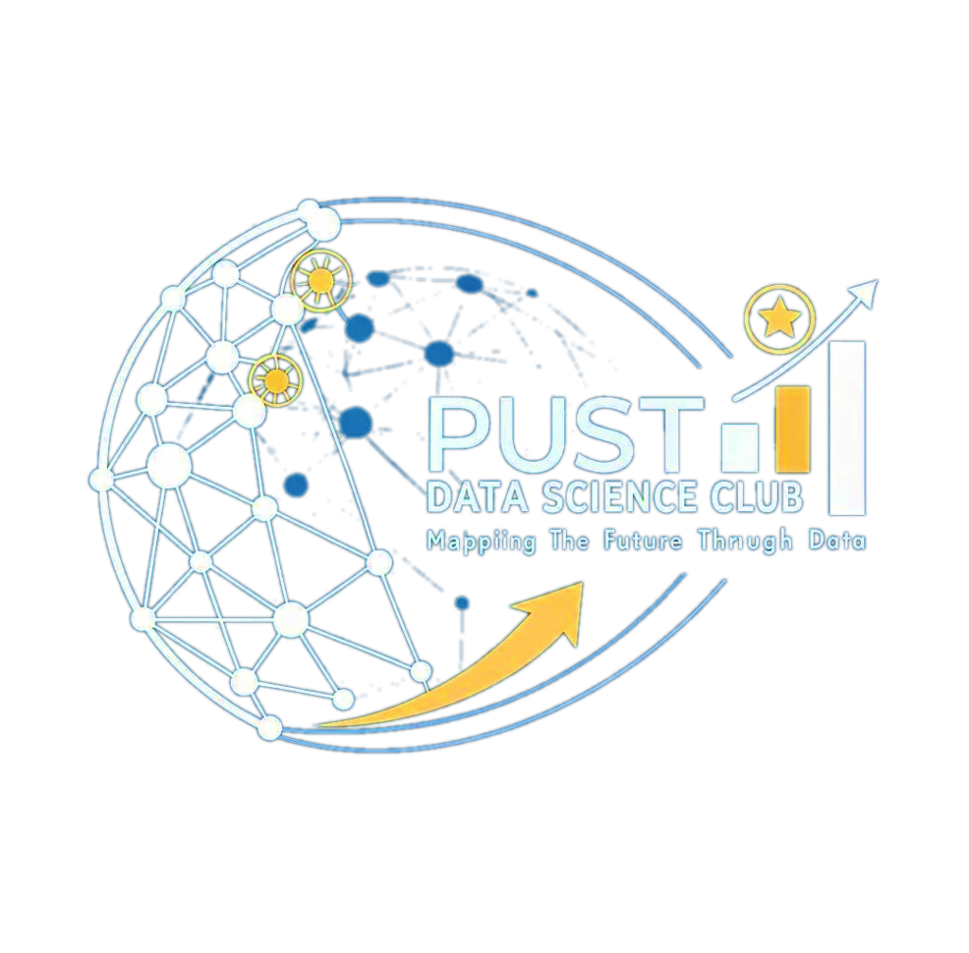
PUST DATA SCIENCE CLUB
Pabna University of Science and Technology
Mapping The Future Through Data

Ref No: PUST/DSC/2026/01 | Date: July 15, 2026
EXECUTIVE COMMITTEE (2026-2027)

We are pleased to introduce the Executive Committee and Advisory Panel of the PUST Data Science Club for the academic term 2026-2027:
Executive Committee
President | Aditto Ahosan Kabbo
Vice President | Md. Humayun Kabir
General Secretary | Md. Bourhan Hossan
Assistant General Secretary | Abyad Raiyan Sawmmo
Organizing Secretary | Md. Safin Reza
Publication Secretary | Tithi Rani Sorker
The Executive Committee will operate for three (3) months under the guidance of the Advisory Panel detailed below:
Advisory Panel
Faculty Advisors
Dr. Md. Shamim Reza  Professor  Department of Statistics | Dr. Sabba Ruhi  Professor  Department of Statistics | Dr. Md. Sarwar Hosain  Professor  Department of ICE
Dr. Md Ekramul Islam  Associate Professor  Department of Mathematics | Most. Mira Khatun  Assistant Professor  Department of Statistics | Nitun Kumar Podder  Assistant Professor  Department of CSE
Rubia Yasmin  Lecturer  Department of Statistics | Dr. Md. Nasif Hossain  Lecturer  Department of Statistics | Md. Miraj Hossain  Lecturer  Department of Statistics
Students Advisors
Md. Nazmus Shakib Shizan Founder & Alumni Advisor | Amran Hossain Tanim  Co-Founder & Alumni Advisor | Arman Ali Ashik  Alumni Advisor
Appointed By:
__________________________  Md. Nazmus Shakib Shizan  Founder  PUST Data Science Club | __________________________  Amran Hossain Tanim  Co-Founder  PUST Data Science Club

